Contemporary & Future Machine Learning in Healthcare

By Joshua Shilts

Abstract

The healthcare industry is an industry that is heavily regulated and because of this slow to change. Machine learning in healthcare has been no exception to this and it has yet to be fully implemented within the industry. This technology is being utilized in the healthcare industry today, and it could further be utilized to improve the quality of healthcare. As it stands machine learning is still being tested out and very few patients get a chance to benefit from the advantages it has to offer. However, the applications of machine learning are increasingly growing and is allowing healthcare to utilize data and analysis techniques that in the future will allow many patients to benefit from real time patient’s data. In this paper we will explore how machine learning is currently being used in the healthcare industry, what learning methods they are utilizing and what can be expected from machine learning in the future.

**Section 1. Introduction**

Machine learning has the potential to change healthcare and better optimize patient care and treatment. Algorithms that predict good prognosis empower healthcare officials to allocate resources optimally and physicians to select better treatment options for patients [1]. Due to this machine learning can and will have a foreseeable impact on how people receive care and treatments. Machine learning has yet to be fully implemented and utilized within the industry due to a lack of accuracy and trust from regulators. However, we will look at Machine learning is being utilized within the Healthcare industry today and how we can and will benefit from it in the future.

**Section 2. How is Machine Learning Being Used Today**

Machine Learning is a subcategory of artificial intelligence that uses a dataset of features and outcomes to learn relations and predictive outcomes. This has become incredibly useful in what is called noisy datasets, or data that contains a large amount of additional meaningless information. Biological datasets contain a lot of noisy data which is where machine learning has the potential to accomplish previously herculean tasks. An algorithm may be trained to predict outcomes such as whether a tumor is benign or malignant from features such as tumor size and the model could then make predictions on new tumors whose outcomes are unknown [1]. This example shows how machine learning can be utilized as a power tool against disease such as cancer to provide patients with a personalized medical treatment option that provides a better outcome for them. This is called predicting prognosis and it has been topic that has had a high level of Machine level implementation to approximate outcomes for patients. Machine learning is also used in prognosis prediction which includes approximating outcomes such as a patient’s disease susceptibility, disease recurrence likelihood, life expectancy, and response to treatment [1]. These factors are important to doctors who with this information could provide better care or proactive care for patients before the exhibit symptoms. Although the factors involved are complex and multifactorial, and thus, it is difficult to provide a definitive prognosis for many conditions [1]. Machine learning can accomplish these goals by learning to analysis and process data in a couple of ways. The two well developed learning methodologies for Machine learning to develop its algorithum to makes decision are supervised and unsupervised learning.

* 1. **Learning Methods**
     1. **Supervised**

Supervised learning is usually utilized in a situation where a researcher knows what they want their output to be and focuses primarily on classification of the data they are processing such as in the fields of radiology and cardiology. This type of machine learning was developed in the 1940s and has become a one of several ways that machine learning has been implemented. Supervised learning focuses on classification, which involves choosing among subgroups to best describe a new data instance, and prediction, which involves estimating an unknown parameter (such as the temperature in San Francisco tomorrow afternoon) [4]. Supervised learning in medicine is widely used today in places such as cardiology, and radiology [2]. In cardiology Machine learning is used to better interpret EKG reading and make a diagnosis based on a pattern recognition. Other researchers have taken this step further and combined machine learning algorithum with neural networks and have found that this new form of analysis can provide quicker and more concise results [5]. Supervised machine learning is already making an impact in this field of medicine and once further refined will only offer by doctors and patients more concise results and better treatment options. Supervised machine learning also impacts radiologist ability to detect diseases and most machine learning done in radiology is supervised [6]. However, the biggest contribution Machine learning can offer radiology is an improved workflow. The workflow improvement it can offer has to do with order scheduling, triage, clinical decision support systems, detection, and interpretation of findings, postprocessing and dose estimation, examination quality control, and radiology reporting [6]. These improvements will not completely replace the role of radiologist however a radiologist will still be required to make the final decision, but the machine learning will make searching for the fine details in an image easier without things like fatigue compromising the analysis. Then a radiologist will be required to look at the big picture and see how or what the algorithum has founds fits into the bigger picture. In these fields machine learning has made a big impact and will continue to improve and advance these fields of health care by enhancing the process of refining and classifying data.

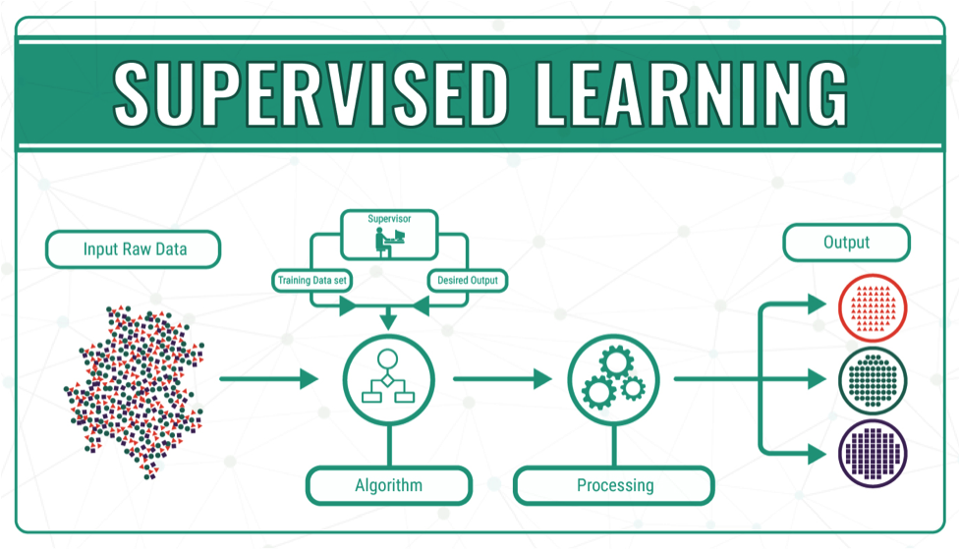

* + 1. **Unsupervised**

Another method of machine learning is called unsupervised learning which is when there are no predictions made on the output. In unsupervised Machine learning, unlabeled data are exposed to the algorithm with the goal of generating labels that will meaningfully organize the data [2]. To accomplish this a lot more training of the algorithm is required to find the pattern occurring naturally in the dataset. This is currently being utilized in medicine in developing precision medicine where an algorithum might start with a group of similar individuals with no know reason for the disease they are experiencing [4]. The unsupervised algorithum would then go through this data and develop groups or data types that are based on patterns observed. This data is then taken to a supervised algorithm for further refinement. Developing this data model though will help people who fall with a specific group making medicine more personalized for an individual who suffers from a specific disease, with specific symptoms that are either apparent or not. Unsupervised learning is useful in identifying meaningful clustering labels that can then be used in supervised training to develop a useful Machine learning algorithm [3]. In another area that this type of machine learning is being utilized is in research for diseases like dementia. In recent study unsupervised machine learning was utilized to try and establish a pattern to the causes and triggers of dementia patients. Comparison of cluster 3 with previously published predicted probabilities of dementia in HRS showed that it identified high likelihood of dementia and removing either cognitive or both cognitive and behavioral measures did not impede accurate classification [7]. This example of unsupervised machine learning show how this technique of machine learning is being utilized to establish patterns to diseases that have escaped our ability to understand them. This will allow us to analysis these patterns and maybe be able to prevent these diseases and even treat them, where before no such option existed. Unsupervised machine learning has shown itself as a tool that has and will continue to show us patterns that were too noisy for us to understand before.

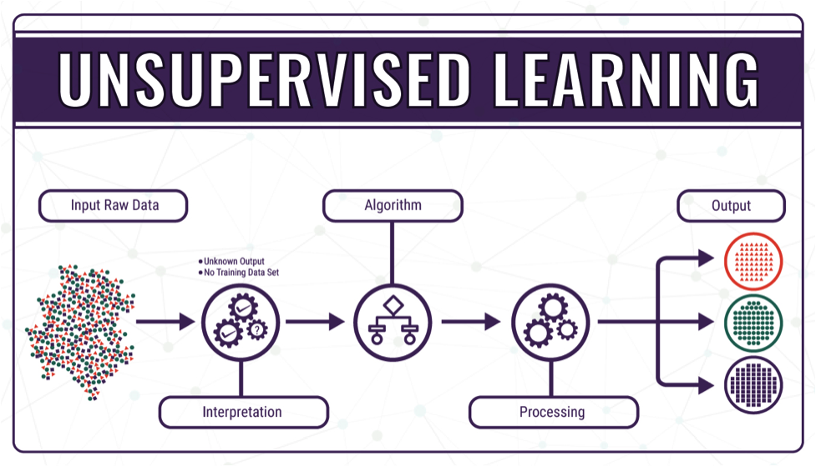

**Section 3. Future Applications**

Machine learning has many applications for the future in the fields of healthcare such as chronic disease management and clinical decision making. Medicine is a field with a lot of data and the time it takes to understand and process new data and turn those into treatments is staggering [3]. Due to machine learning this is beginning to change, and data is being processed at a much higher rate than before and new treatments are being developed in response to that. [3] Scarcely a week goes by without a research lab claiming that it has developed an approach to using AI or big data to diagnose and treat a disease with equal or greater accuracy than human clinicians. [3] In a lot of these examples, it appears that machine learning will replace some professions, but it is more likely that it will become another tool in the toolbox for clinical research and decision making. Radiology is another field that in the future where machine learning will become an invaluable tool. Image gathering in medicine has increased significantly and will eventually overwhelm radiologist. However, if machine learning is added to the toolbox of radiologist it offers an opportunity to unburden them and allow them to focus on images and patients that require their attention. ML would reduce the burden and provide consistent 24-hour service, whereas human radiologists may make errors in circumstances such as overnight shifts [1]. This shows how machine learning will not replace radiologists but give them more tools to make their work more efficent and precise in the future. Chronic disease treatment will also be a field that in the future will benefit from machine learning by providing proactive care delivery and more personalized medicine. For example, machine learning could be used to discover substages of a disease and allow physicians more time to apply treatments or to mitigate the effects of the disease. In Parkinson's disease, we think that machine learning could help us define subtypes or stages of the condition and by forming those subpopulations, we could do better patient management, as well as more targeted therapeutic discovery [4]. In addition, personalized treatment will offer better results account for the variation within patient and characterize it. Much of the use of machine learning in the development of personalized medicines is focused on the treatment of individuals with overt disease such as identifying the underlying pathology, determining which interventions might make most sense to provide given what is known about that pathology and the mechanism of action of the intervention, and testing to see if the intervention works [5]. These applications of machine learning have a future within the fields of healthcare and in the coming years will be tested and hopefully used to provide better chronic disease management and clinical decision making.

**Section 4. Discussion**

It is apparent thought the gathered research that machine learning is a tool that is going to become more intrinsic in the future for healthcare. One thing that is holding machine learning back is the lack of large quality datasets that could be utilized to further advance both unsupervised and supervised machine learning methodologies. The quality datasets are hard come by since a lot of patient records are usually incomplete. [1] This is due to that fact that biological samples collected by researchers are usually not shared which leaves gaps in data that is detrimental to the machine learning process. All these set back though are human problems that with enough incentive could be remedied. As researchers and big corporations become more aware of the hurdles blocking this technology, ways will be uncovered, or new technologies will make advancements in this field more feasible. Therefore, machine learning in medicine is a tool that will eventually become available, when is dependent on research and the advancement of new and emerging technologies. Machine learning is not a tool that replace humans in healthcare but will become a part of it that will enable better results and allow professionals to process more patient samples and data. In these ways machine learning will make an impact on the future of medicine while the contemporary processes are further refined and vetted.

**Section 5. Conclusion**

In this paper we look at how machine learning is being utilized in the healthcare field, what the different learning types are, and how it will be use in the future. The learning methods of machine learning show how we can process vast amounts of data in different ways that allow researchers to utilize them. The patterns that are developed in unsupervised learning and then refined with supervised learning open new avenues in treatment and understanding of disease while streamline clinical services and care. In the future machine learning will become an intrinsic part of healthcare that allows doctors and researchers to develop new treatment and cures for existing diseases and provided proactive care for their patients.

# Bibliography

|  |  |
| --- | --- |
| [1] | V. C. Chloe Gui, 2017. [Online]. Available: https://ojs.lib.uwo.ca/index.php/uwomj/article/download/2060/1352/.. |
| [2] | L. M. P. R. W. F. a. J. R. G. Marc Kohli, "American Journal of Roentgenology," ARRS, 2017. [Online]. Available: https://www.ajronline.org/doi/full/10.2214/AJR.16.17224. |
| [3] | R. K. Thomas Davenport, "The potential for artificial intelligence in healthcare," 2019. [Online]. Available: https://www.ncbi.nlm.nih.gov/pmc/articles/PMC6616181/. |
| [4] | J. Kent, "Applying Artificial Intelligence to Chronic Disease Management," 2020. [Online]. Available: https://healthitanalytics.com/features/applying-artificial-intelligence-to-chronic-disease-management. |
| [5] | P. Nicholas J. Schork, "ARTIFICIAL INTELLIGENCE AND PERSONALIZED MEDICINE," 2020. [Online]. Available: https://www.ncbi.nlm.nih.gov/pmc/articles/PMC7580505/. |
| [6] | D. Faggella, "7 Applications of Machine Learning in Pharma and Medicine," 4 3 2020. [Online]. Available: https://emerj.com/ai-sector-overviews/machine-learning-in-pharma-medicine/.. |
| [7] | R. C. Deo, "Machine Learning in Medicine," 3 2018. [Online]. Available: https://www.ncbi.nlm.nih.gov/pmc/articles/PMC5831252/. |
| [8] | A. Y. H. M. H. C. B. A. Y. N. Pranav Rajpurkar, "Cardiologist-Level Arrhythmia Detection with Convolutional Neural Networks," [Online]. Available: https://arxiv.org/pdf/1707.01836.pdf. |
| [9] | M. M. a. O. K. M. M. M. M. M. S. D. P. A. E. S. M. M. O. S. P. P. J. R. G. M. P. V. P. M. M. J. A. B. M. a. K. J. D. D. P. Garry Choy, "Current Applications and Future Impact of Machine Learning in Radiology," 10 2018. [Online]. Available: https://www.ncbi.nlm.nih.gov/pmc/articles/PMC6542626/. |
| [10] | E. B. K. Y. Laurent Cleret de Langavant, "Unsupervised Machine Learning to Identify High Likelihood of Dementia in Population-Based Surveys: Development and Validation Study," 7 2017. [Online]. Available: https://www.jmir.org/2018/7/e10493/. |
| [11] | L. C. F.-M. A. R. A. M. R. Z. W. E. A. L. a. I. B. Victor Ponomariov, "Artificial Intelligence versus Doctors' Intelligence: A Glance on Machine Learning Benefaction in Electrocardiography," 2017. [Online]. Available: https://www.ncbi.nlm.nih.gov/pmc/articles/PMC6941587/. |